Adapter Design Pattern
Wednesday, May 6, 2020
1:44 PM
Definition:

Match interfaces of different classes

The Adapter Design Pattern allows incompatible classes to interact with each other by converting the interface of one class into an interface expected by the clients.

Leveraging on Adapter pattern improves reusability of old functionality.

When:

A class need to be reused which does not have an interface.
We need to work through a separate Adapter that adapts the interface of an existing class without changing it.
Clients don't know whether they work with a Target class directly or through another alternative that does not have the Target interface.

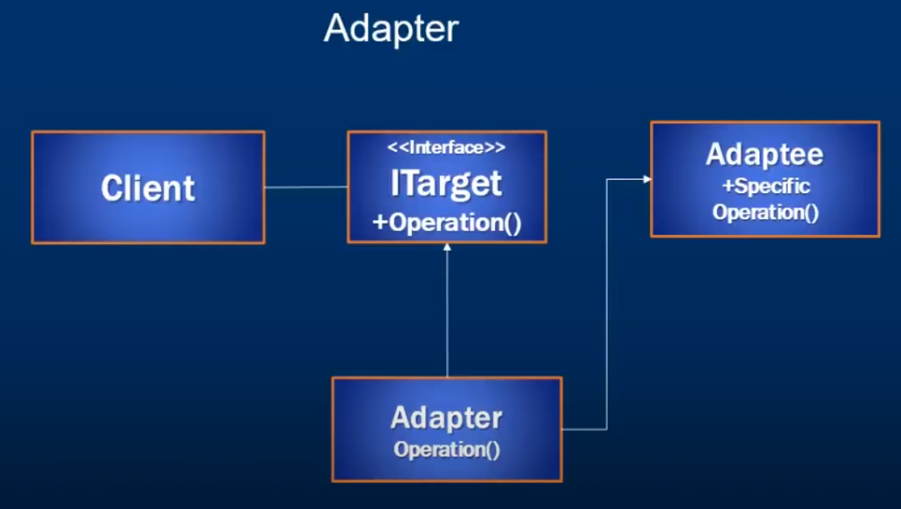

Benefits:
重用：
重用现存的类，解决了现存类和复用环境要不一致的问题。
低耦合：
对修改封闭，对扩展开放，无需修改原有类的代码。

Shortcomings:
过多使用适配器，会让程序看起来很难懂。

Using case example:
大多数使用第三方库的应用程序使用适配器作为应用程序和第三方库之间的中间层，以将应用程序与库分离。如果必须使用另一个库，则只需要新库的适配器，而无需更改应用程序代码。

Add: Create a intermediary class, do some conversion work in the class and return the desired data.

